**Latin America - Physical Map**

The primary purpose of a physical map is to show ___________________

like _________________, ________________, and ______________.

Their topography style (or relief) presents an overall

better picture of the local terrain.

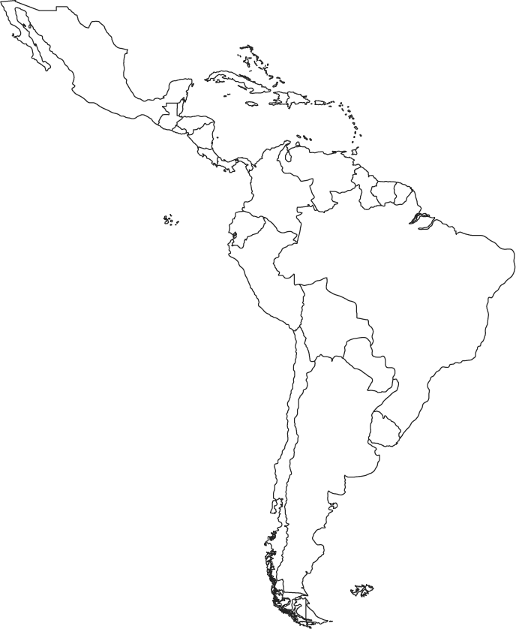

Use a pen to label the following eight physical features on the map:

* Amazon River
* Caribbean Sea
* Gulf of Mexico
* Pacific Ocean
* Panama Canal
* Andes Mountains
* Sierra Madres Mountains
* Atacama Desert
* Atlantic Ocean

1. Color the Pacific Ocean, Amazon River, the Atlantic Ocean, and the Gulf

of Mexico **dark blue.**

2. Color the Caribbean Sea **LIGHT BLUE (or TEAL)**

3. Draw a **RED box** where the Panama Canal is located.

4. Draw triangle symbols around the Andres Mountains and color them

**green.**

5. Draw triangle symbols around the Sierra Madre Mountains and color

them **yellow.**

6. Color the Atacama Desert **brown.**

Answer these questions using the map:

1. What sea is Cuba surrounded by? ______________________________

2. What gulf borders Cuba to the north?___________________________

3. What ocean borders Brazil’s eastern coast?______________________

4. What major river flows through northern Brazil? _________________