Name:__________________________________ Class:___________ Date:___________

Statistics - Interquartile Range (IQR) – Homework

For Exercises 1-2, identify the range, median, Q1, Q3, and interquartile range (IQR).

1. Ages of mall shoppers

13 33 21 18 17 72 17 55

31 27 47 29 19 18 25

2. Class grades on a history exam

97 86 93 76 70 85 82 83 99 100 96

3. Emily works at a fitness center. She recorded the heart rates of some people immediately after they exercised. Her data are shown below.

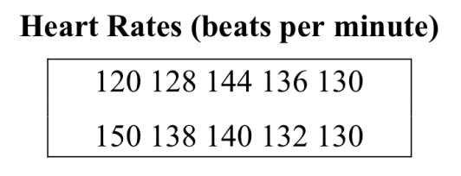

a. What is the range of the middle 50% of the data Emily collected?

Emily measured the heart rates of two more people. When these heart rates were added to the data set, the range increased.

b. Explain what must be true of the two additional heart rates in order for the range to increase.

