6.NS.6b Name ______________________
Period _____ Date ___________
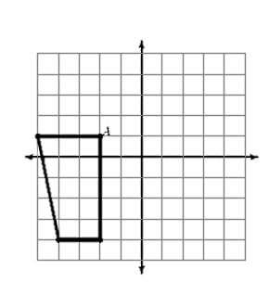
Label the x- and y-axis below. Reflect the following shape over the y-axis. Record all of the coordinates below.

Coordinates of original shape: Coordinates of the reflective shape:
A = A=
C = C=
S = S=
V = V=

How do the coordinates of both shapes compare?
______________________________________________________________________________________________________________________

