[](http://www.google.com/url?sa=i&source=images&cd=&cad=rja&docid=zQ0fGQFou71pwM&tbnid=Zui2_b2cuXbV_M:&ved=0CAgQjRwwAA&url=http://www.debrady.com/catalogue/hanging/compassrose.htm&ei=dIh9Uay0OILe8ASBxIBQ&psig=AFQjCNFFdoJzyBFgW7vrs2e9mVeZwhzYBQ&ust=1367267829026727)[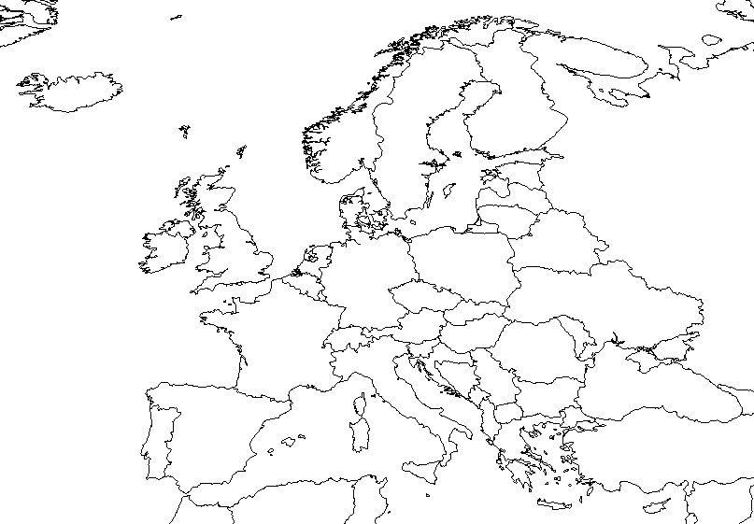](http://www.google.com/url?sa=i&source=images&cd=&cad=rja&docid=JhUUGtUtO8jd6M&tbnid=3N8DrCBfvYFDrM:&ved=0CAgQjRwwAA&url=http://geography.about.com/library/blank/blxeurope.htm&ei=7od9Ud-HOomY8gTmnYCYCw&psig=AFQjCNFX61CxafNjvXaAt-gWyAtEYRPnLA&ust=1367267695019814)