Esperanza Computer Challenge

{Curiosity: I seek to learn more.}

Due: August 29

The challenge is to answer the questions below and to create a flow chart of your computer search.

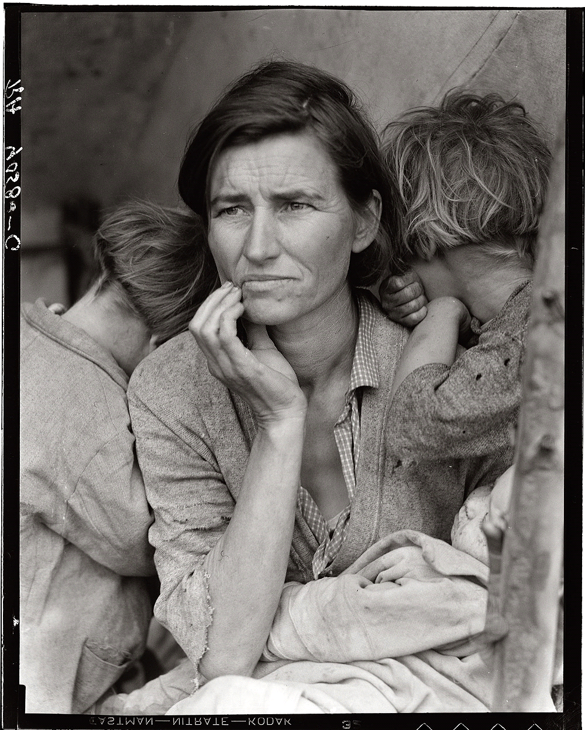

Using your technology skills can you answer these questions?
Who is in this picture?
Why is this picture significant?
How does the picture connect with the book, Esperanza Rising?
Your answers must be in complete sentences or in paragraph format.
Please include a flow chart of your search. ( a list of the sites you visited trying to find the information)
Your answers must be written in complete sentences and supported by evidence from your sources. It may be handwritten or typed. {Craftsmanship: I produce high-quality work that is visually appealing and organized}
If you do not have internet access, please let me know and we will make arrangements for you to work on this before the school day begins.
{If you get stuck...shoot me an email and I will provide a hint}

Your parents can help.
However, if you allow your parents to do too much then you are denying yourself the opportunity to learn!

