Dear Parents,

I would like to invite you to read with your sixth grader this year beginning with the book, Esperanza Rising. I believe you and your child will enjoy this historic fiction as it closely follows the real life experience of a young woman in the 1920s. {Moment of truth-the first chapter is dull but I promise you will quickly become hooked} Esperanza is a complicated character. She made me wanted to hug her, shake her, cry for her, and cheer for her. It will make you take a good hard look at the things you value.

Reading with your child is simple. There is no right or wrong way to do this. The important thing is to make it enjoyable and discuss the story.

You may:

- read independently and then discuss the section.
- have your child read aloud to you.
- take turns reading.
- read it to your child. (Yes, you may be the reader!)

Middle school children are notorious for shutting down and not sharing with their parents. Reading together prompts children to open up and talk. Now is the time that your child will be developing his/her “world view”. Your child will begin to form opinions on many social, political, and moral issues. All of the books we will read this year broach these issues. I know, as a mother, it was important to me to share in this process with my child. I hope you will find the experience rewarding.

Esperanza Rising touches on:

- the death of a parent.
- grief.
- greed
- the meaning of rich (can you be rich and poor at the same time).
- immigration.
- labor unions/strikes.
- the cost of standing up for what you believe in.
- social class (land owners/servants).
- discrimination within the same racial group
- the value of hard work.
- self-image.

For each book we will try to think like the character, think like the reader, and think like the author. At the end of this unit, your child will be asked to write a five paragraph essay explaining how Esperanza grows and changes during the course of the story using evidence from the text as support.

I have included a reading schedule, but you are welcome to read ahead. I hope that you and your child enjoy Esperanza Rising and that it provokes some rich family discussions.

August 12  pg 18 | August 15  pg 57 | August 19  pg 85 | August 22  pg 100 | August 26  pg 138
August 29  pg 153 | September 2  pg 164 | September 5  pg 198 | September 9  pg 224 | September 12  pg 253

Esperanza Computer Challenge

{Curiosity: I seek to learn more.}

Due: August 29

The challenge is to answer the questions below and to create a flow chart of your computer search.

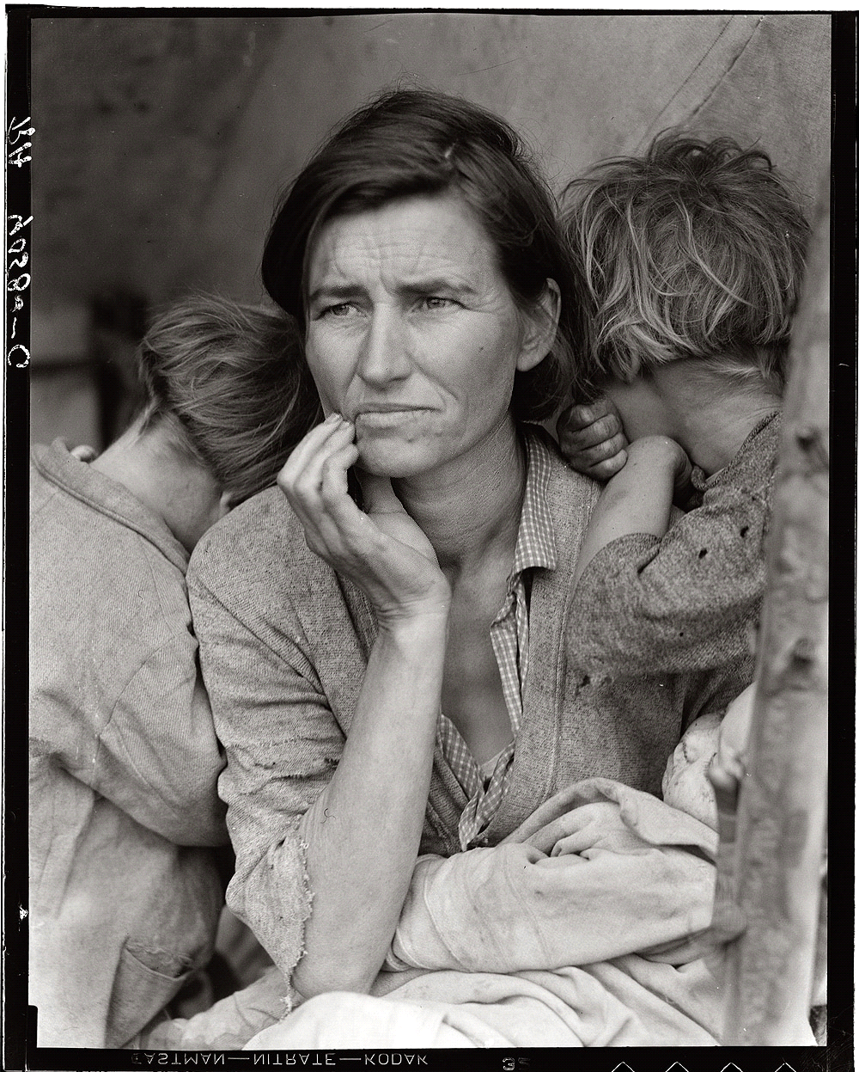

Using your technology skills can you answer these questions?
Who is in this picture?
Why is this picture significant?
How does the picture connect with the book, Esperanza Rising?
Your answers must be in complete sentences or in paragraph format.
Please include a flow chart of your search. ( a list of the sites you visited trying to find the information)
Your answers must be written in complete sentences and supported by evidence from your sources. It may be handwritten or typed. {Craftsmanship: I produce high-quality work that is visually appealing and organized}
If you do not have internet access, please let me know and we will make arrangements for you to work on this before the school day begins.
{If you get stuck...shoot me an email and I will provide a hint}

Your parents can help.
However, if you allow your parents to do too much then you are denying yourself the opportunity to learn!

