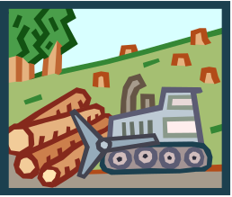
Name: ___________________

Canada’s Environmental Issues KEY

Environmental Issue | Description of Problem | Illustration of Problem | Solution
Acid Rain & Pollution of the Great Lakes | - Coal-burning factories, cars, & trucks release chemicals that pollute the air  - Acid Rain can damage or kill trees and pollute lakes enough to kill fish.  - Houses, buildings, and statues can also be damaged. | 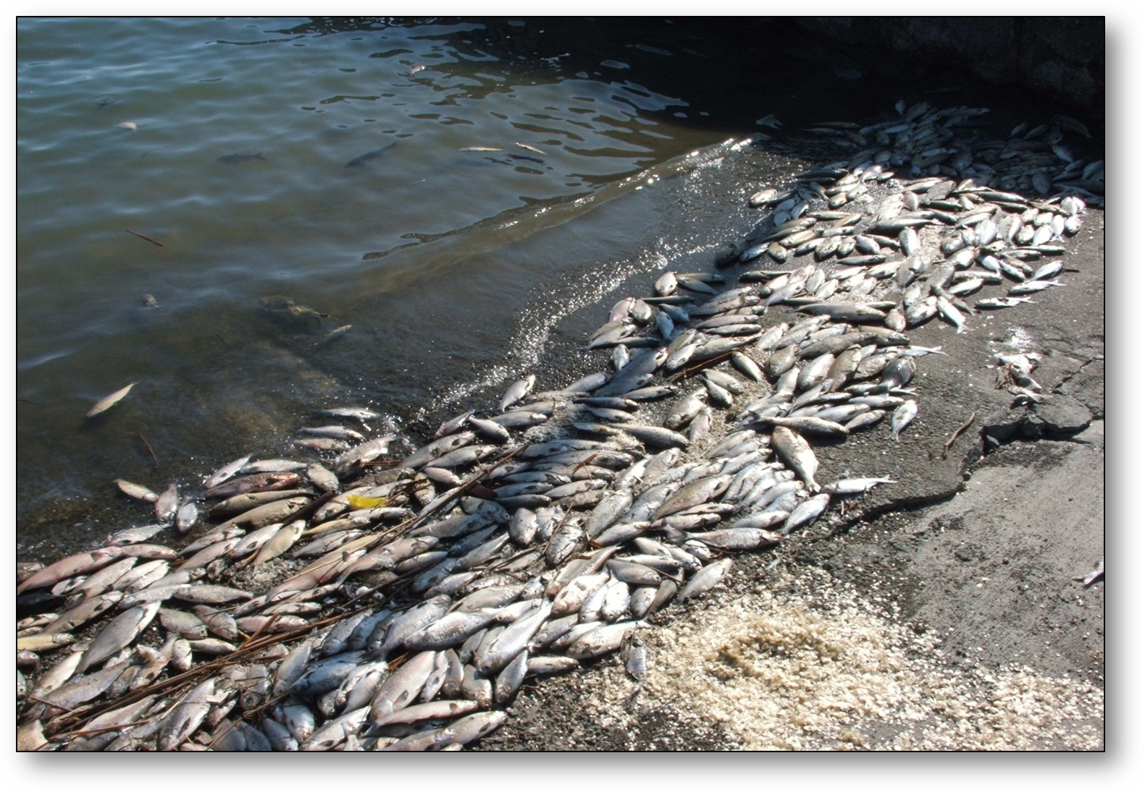 | - They are building factories that don’t pollute the air.  - Laws have been passed that require cars to produce less pollution.  - They are encouraging people to walk or ride bikes/buses, rather than driving.
Extraction of Natural Resources on the Canadian Shield | - Blasting & digging with heavy machinery causes the land around mines to be damaged and the environment is often ruined.  - Mining processes release harmful chemicals into the air, which causes acid rain. | 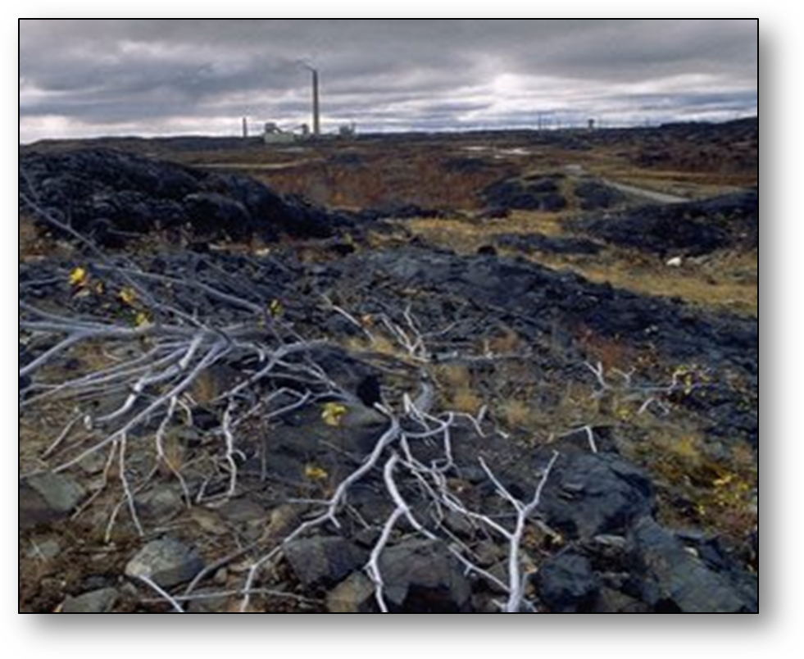 | - Canada’s government has made new rules about mining.  - Some rules reduce the amount of pollution allowed in waterways.
Deforestation of Timber Resources | - Most timber companies cut all the trees in a given area, leaving large treeless gaps in the forest (called “clear-cutting”).  - This reduces water quality, causes erosion, & kills animals’ habitats.  - Heavy machinery leaves the forest floor compacted and makes it hard for new growth to start. | 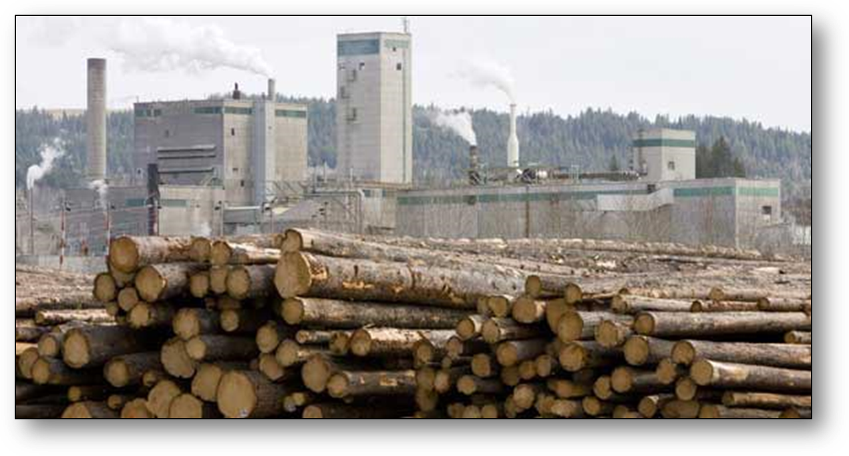 | - Government and industries are working together to manage use of the forests.  - Hundreds of millions of seedlings are planted each year.

