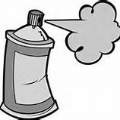
Graffiti Board
Your Task: Write down everything that you’ve learned about Australia’s Economy—facts, statistics, vocabulary, etc., ALL over the wall. Finally, switch papers with a partner. Read your partner’s wall and respond with your thoughts and feelings about the information. Use different colors so it looks like real graffiti!
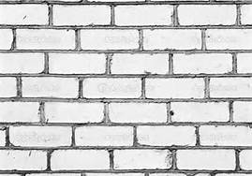
Australia’s
Economy

