**Latin America - Political Map**

Political maps are designed to show ___________________ boundaries of ____________________, _________________ and ________________. They can also indicate the location of ________________ cities, and they usually

include __________________________ bodies of water.

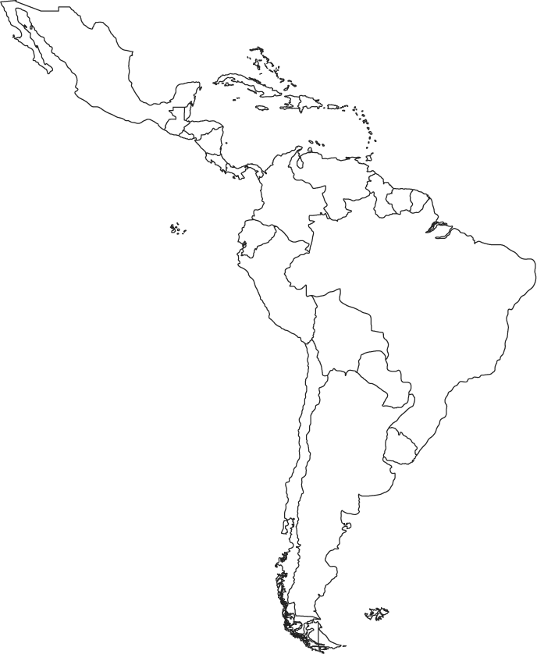

Answer these questions using your map.

1. What is the largest country in South America? _______________

2. What country is an island just south of Florida? ______________

Label the following areas on the map with its number.

3. Brazil

4. Cuba

5. Bolivia

6. Colombia

7. Haiti

8. Mexico

9. Panama

10. Venezuela