**Latin America - Physical Map**

The primary purpose of a physical map is to show ___________________________ like

________________________, ______________________, and __________________________.

Their topography style (or relief) presents an overall better picture of the

local terrain.

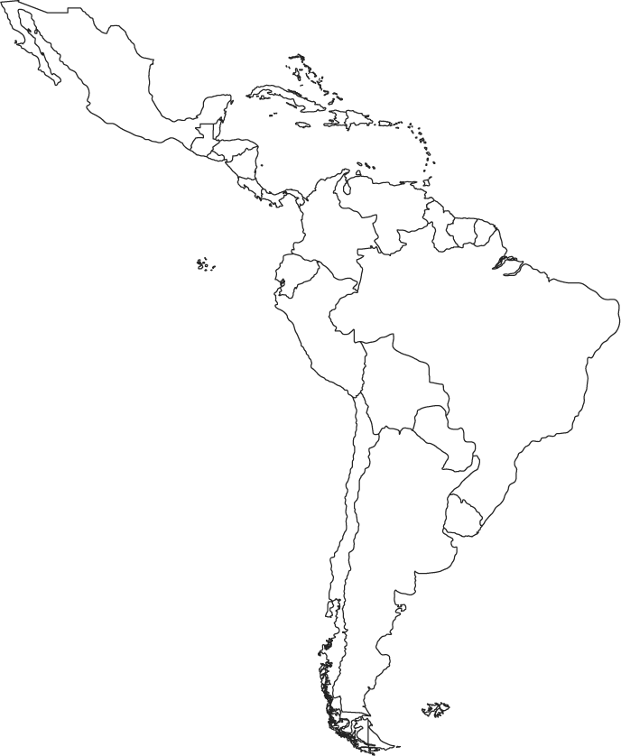

1. Color the Pacific Ocean, Amazon River, the Atlantic Ocean, and the Gulf of Mexico dark blue. Then write their initials in dark black over the blue.

2. Color the Caribbean Sea LIGHT BLUE (or TEAL)

3. Draw a RED box where the Panama Canal is located.

4. Draw triangle symbols around the Andres Mountains and color them green.

5. Draw triangle symbols around the Sierra Madre Mountains and color them yellow.

6. Color the Atacama Desert brown.

**Answer these questions using the map:**

1. What sea is Cuba surrounded by? ______________________________

2. What gulf borders Cuba to the north? ___________________________

3. What ocean borders Brazil’s eastern coast? ______________________

4. What major river flows through northern Brazil? _________________