
Name _________________________________________________ Date _________________
Ratios and Proportions/Ratios Lesson #2/6.RP.1 – Class notes

VIDEO ACTIVITY:
We will practice writing ratios by watching a video on the world. This video pretends that there is a village of 100 people who equally represent every country and language in the world. Watch the “If the World Were a Village Video” and fill in the blanks!

- For every 100 people in the world, there are _____ people from Asia.

- For every 100 people in the world, there are _____ people from Africa.

- For every 100 people in the world, there are _____ people from North America.

- For every 100 people in the world, there are _____ people from Central and South America.

- For every 100 people in the world, there are _____ people from Europe.

- For every 100 people in the world, there are _____ people from Oceania.

- ____ out of every 100 people in the world speak Chinese.

- ____ out of every 100 people in the world speak English.

- ____ out of every 100 people in the world speak Hindi.

- ____ out of every 100 people in the world speak Spanish.

- ____ out of every 100 people in the world speak Bengali.

- ____ out of every 100 people in the world speak Arabic.

- ____ out of every 100 people in the world speak Russian.

- ____ out of every 100 people in the world speak Portuguese.

Mini-Lesson:
- For every can be used to replace the fraction bar, colon : or word “to” in a ratio


Fill in the answers as we go through today’s lesson.

(ex 1) Write a ratio in words comparing beaks to wings for an eagle.
Step 1: Write a ratio of beaks to wings

Step 2: Write this ratio in words


(ex 2) In a class election, Juan received 20 votes and Kevin received 8 votes. Write a ratio in words comparing Juan and Kevin’s votes.
Step 1: Write a ratio of Juan’s votes to Kevin’s votes

Step 2: Simplify the ratio

Step 3: Write this ratio in words


(ex 3) Kaylee buys 2 posters that are the same size. She wants to hang up each poster using the following push pins. Write a sentence to answer the question.
How many push pins should she use for each poster

Assessment:
1) We can write ratios as sentences using the phrase, _______ _________ .

2) A human being has ____ fingers for every _____ nose.

3) A brownie recipe calls for 2 cups of white sugar, 2 cups of brown sugar and 1 cup of flour. Write a sentence comparing cups of flour to cups of brown sugar.

(ex 4) Brian also wants to decorate his room. He has 4 posters that need the same ratio of push pins as Kaylee’s Posters.

How many push pins does Brian need to hang up his posters?
- Draw a picture and explain your steps!


Practice:

- Write a ratio in three ways comparing ears to legs for a pig.

- Fill in the sentences below based on your answer in #1.

- A pig has ____ ear for every ____ legs.

- For every, ____ legs for every ____ ear.

- What other animal has the same ratio of ears to legs?

- What animal has a different ratio of ears to legs?
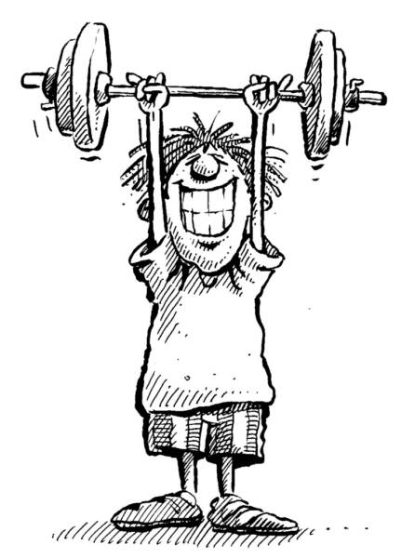
5) Alex spends every afternoon at the gym. Here is a chart to show his activities.
Activity | Time (minutes)
Running | 25
Lifting Weights | 35

- Write a ratio comparing Alex’s time spent running to lifting weights.

- Write a ratio comparing Alex’s time spent lifting weight to running.

- Write a sentence comparing Alex’s time spent running to lifting weights using the words for every.
- Can you write a second sentence comparing running to lifting weights using for every?
Name _________________________________________________ Date _________________
Ratios and Proportions/Ratios Lesson #2/6.RP.1 – Class notes

VIDEO ACTIVITY:
We will practice writing ratios by watching a video on the world. This video pretends that there is a village of 100 people who equally represent every country and language in the world. Watch the “If the World Were a Village Video” and fill in the blanks!

- For every 100 people in the world, there are __61___ people from Asia.
- For every 100 people in the world, there are ___13__ people from Africa.
- For every 100 people in the world, there are __5___ people from North America.
- For every 100 people in the world, there are __8__ people from Central and South America.
- For every 100 people in the world, there are __12___ people from Europe.
- For every 100 people in the world, there are __1___ people from Oceania.
- __22__ out of 100 people in the village would speak Chinese.
- __9__ out of 100 people in the village would speak English.
- __8__ out of 100 people in the village would speak Hindi.
- __7__ out of 100 people in the village would speak Spanish.
- __4__ out of 100 people in the village would speak Bengali.
- _4__ out of 100 people in the village would speak Arabic.
- __3__ out of 100 people in the village would speak Russian.
- __3__ out of 100 people in the village would speak Portuguese.

Mini-Lesson:
For every 100 people in the village, there are 61 people from China.

- For every can be used to replace the fraction bar, colon : or word “to” in a ratio

Fill in the answers as we go through today’s lesson.

(ex 1) Write a ratio in words comparing beaks to wings for an eagle.
Step 1: Write a ratio of beaks to wings
1 beak: 2 wings

Step 2: Write this ratio in words
An eagle has 1 beak for every 2 wings.

(ex 2) In a class election, Juan received 20 votes and Kevin received 8 votes. Write a ratio in words comparing Juan and Kevin’s votes.
Step 1: Write a ratio of Juan’s votes to Kevin’s votes
20 votes to 8 votes

Step 2: Simplify the ratio
5 votes for Juan to 2 votes for Kevin

Step 3: Write this ratio in words
For every 5 votes that Juan received, Kevin received 2 votes.

(ex 3) Kaylee buys 2 posters that are the same size. She wants to hang up each poster using the following push pins. Write a sentence to answer the question.
How many push pins should she use for each poster?
4 push pins to 1 poster
For every 1 poster, Kaylee should use 4 push-pins.

For #1 and #2, fill in the blanks:
1) We can write ratios as sentences using the phrase, for every .
- A human being has 10 fingers for every 1 nose.
- A brownie recipe calls for 2 cups of white sugar, 2 cups of brown sugar and 1 cup of flour. Write a sentence comparing cups of flour to cups of brown sugar.
1 cup of flour: 2 cups of brown sugar
A brownie recipe has 1 cup of flour for every 2 cups of brown sugar.

