Name _________________________________________________ Date _________________

**Ratios and Proportions - 6.RP.1 Lesson 1 – HOMEWORK**

RP.1 - I can use a variety of representations for ratios (pictures, illustrations, etc.).

I can write a ratio in different forms – as a fraction (a/b), with a colon (a:b), and in word

form (a to b)

I can use models and pictures to develop a ratio.

**Simplify the following fractions:**

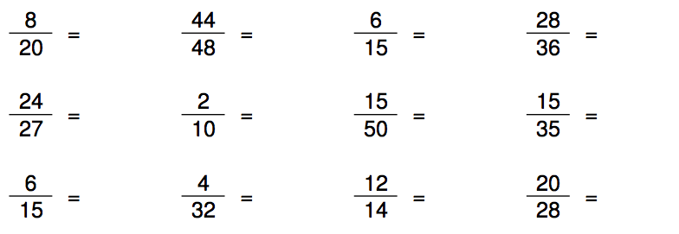

1. Look at your class notes, what are the 3 ways to write a ratio?

1) ________________

2) ________________

3) ________________

1. Write a ratio in 3 ways comparing paint cans to paint brushes.

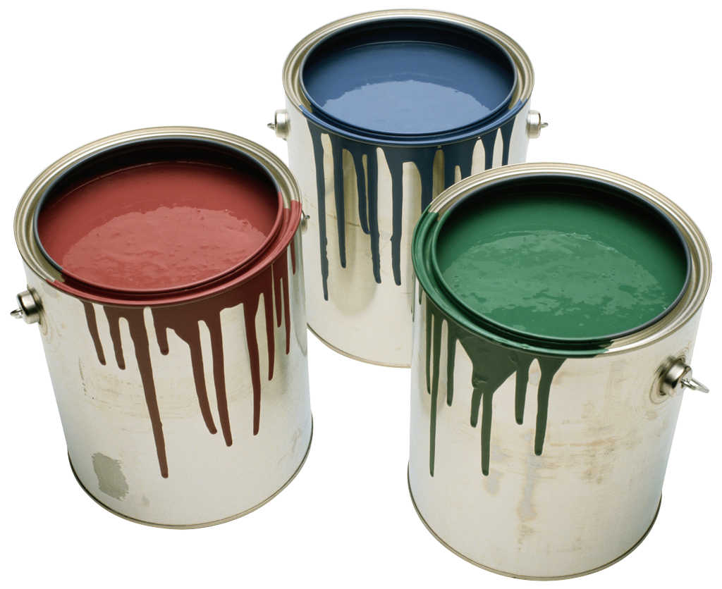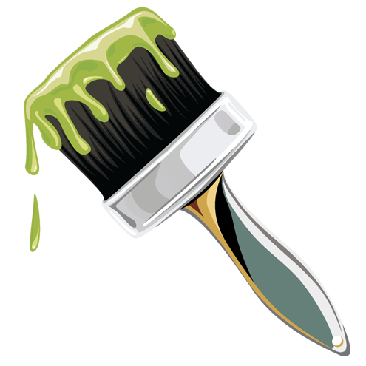

_______ paint cans ___ paint cans: _____ paint brushes

paint brushes

___ paint cans to _____ paint brushes

1. Write the ratio of paper clips to erasers as a fraction using labels. Make sure to label your numerator and denominator.

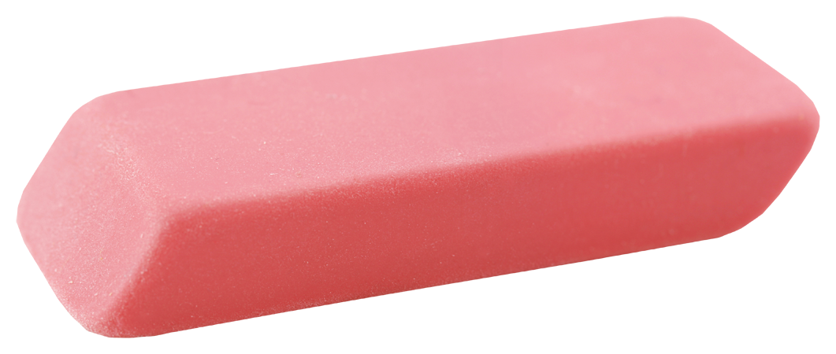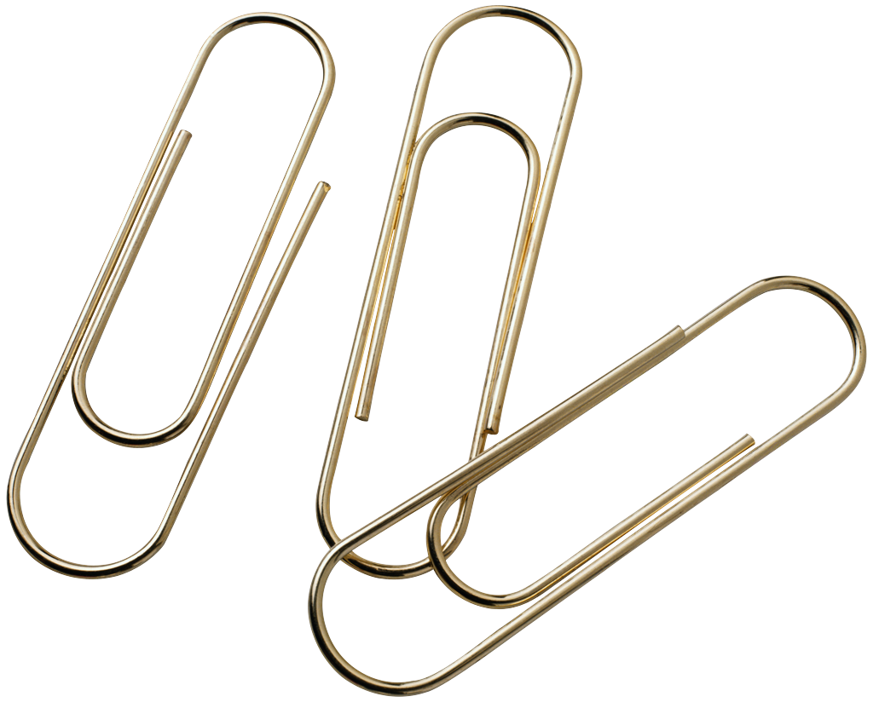

1. Write a ratio of erasers to paper clips in two different ways.
2. Write a sentence to explain the ratio of paper clips to erasers.
3. Trevor has 9 quarters, 6 nickels and 15 dimes in his wallet purse. Write a ratio in three ways to show the relationship of nickels to dimes. Make sure to simplify your answers and label your ratios!

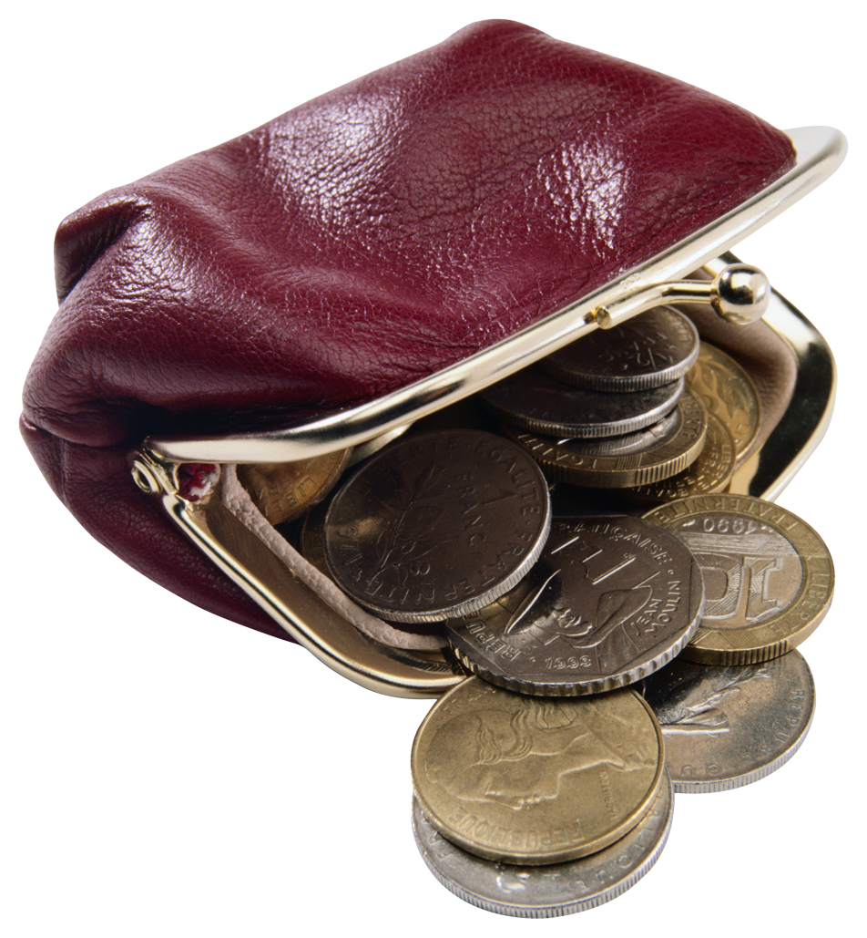

_________________ ___________________ ___________________

1. Juan downloaded 30 songs from I-Tunes. The following is a table of Juan’s songs that show the types of songs and number of songs that he bought.

|  |  |
| --- | --- |
| **Types of Songs** | **# of Songs** |
| Hip-Hop | 9 |
| Pop | 15 |
| Rap | 6 |

1. Find the ratio of rap songs to pop songs.
2. Find the ratio of hip-hop songs to total songs.
3. Write a sentence to explain the meaning of the ratio in part (b).