Name _________________________________________________ Date _________________
Ratios and Proportions/Ratios/6.RP.1 – Class notes
Turn and Talk:
- Have you ever had Lucky Charms cereal?

- Do you think there are there more marshmallows or oat pieces in a box of Lucky Charms? ________________________

I have divided up a box of Lucky Charms into small baggies. Count your marshmallows and oats and record on class chart. Then we will add together to come up with a guess for our box.

- Predict how many marshmallows pieces are in 1 box. ________

- Predict how many oat pieces are in 1 box. ________

There are _______ marshmallow pieces and _______ oat pieces in 1 box of Lucky Charms.

A ratio is ______________________________________________________________________________.

We can write a ratio in 3 ways using,
1) a fraction

2) the word “to”

3) a colon

Write a ratio comparing # of pizzas to # of people for each picture.

Picture #1 Picture #2

Talk to your partner
- How are the ratios above alike?

- Does the order matter when writing a ratio?

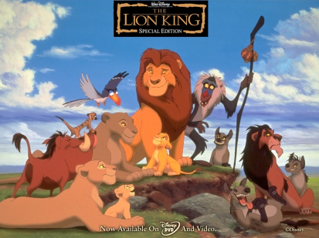
Partner Work:
Use the picture to write a ratio in 3 ways
comparing # of lions and # of birds. Explain what this ratio means.

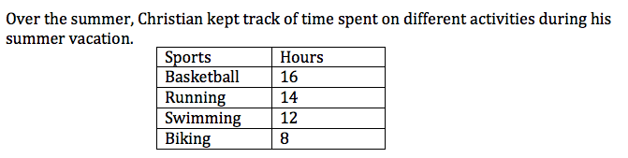
- Write in simplest form the ratio of Biking to Basketball.

- Write in simplest form the ratio of Christian’s time spent running
to total hours of activities.

SUMMARY
- A ratio is a comparison of two different __________________________.

- We can write a ratio in ______ different ways.

3) Ratios can be written as

- Write a ratio comparing number of boys to girls in our class in 3 different ways.

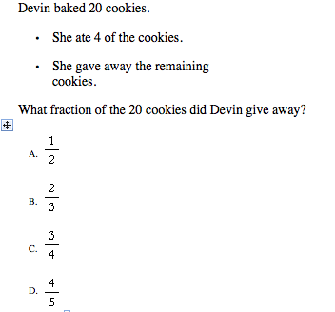
ASSESSMENT:

Name __________________________________________ Date _________________ Classwork
RP.1 - I can use a variety of representations for ratios (pictures, illustrations, etc.).
I can write a ratio in different forms – as a fraction (a/b), with a colon (a:b), and in word form (a
to b)
I can use models and pictures to develop a ratio.
Simplify the following fractions:
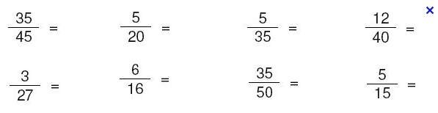
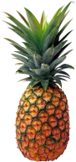
- Write a ratio as a fraction in simplest form comparing peppers to pineapples.

_______________________

- Write the ratio of peppers to pineapples in two different ways than a fraction.

_______________________ __________________________
- Angela has 6 quarters, 3 nickels and 12 dimes in her purse. Write a ratio in three ways to show the relationship of dimes to quarters.
_________________ ___________________ ___________________

- Maria has read many books over the school year and keeps track of these books in the table below.
Types of Book | # of Books
Fantasy | 6
Non-Fiction | 4
Mystery | 10

- Find the ratio of mystery books to fantasy books.

- Find the ratio of non-fiction books to total books.

- Write a sentence to explain the meaning of the ratio in part (b).

