Area in the Real World - Problem Set
I can apply my understanding of shapes to solve real-world problems.

- Below is a drawing of a wall that is to be covered with either wallpaper or paint. The wall is $8 ft.$ high and $16 ft.$long. The window, mirror, and fireplace will not be painted or papered. The window measures$18 in.$ by$14 ft.$ The fireplace is $5 ft.$wide and $3 ft.$ high, while the mirror above the fireplace is$4 ft.$ by$2 ft$.
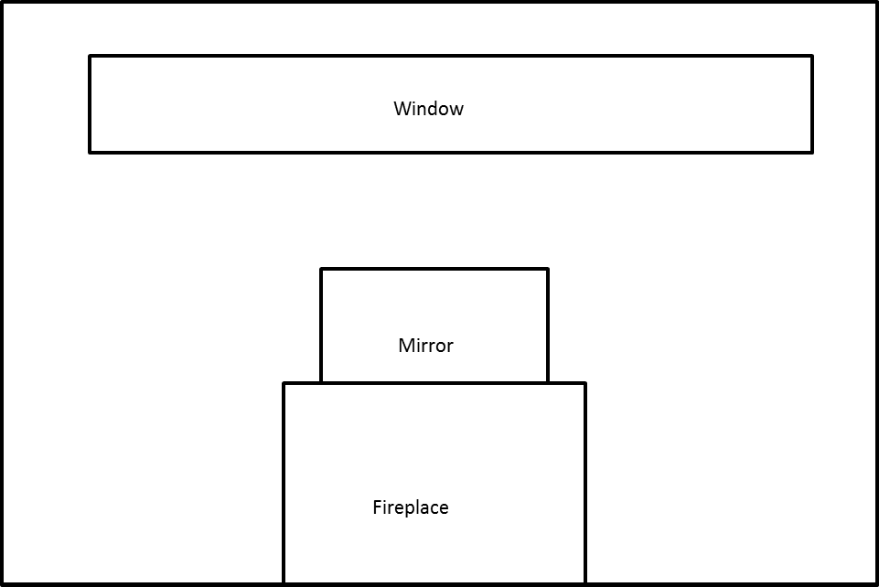

  - How many square feet of wallpaper are needed to cover the wall?

  - The wallpaper is sold in rolls that are $18 in.$wide and $33 ft.$ long. Rolls of solid color wallpaper will be used, so patterns do not have to match up.
    - What is the area of one roll of wallpaper?

    - How many rolls would be needed to cover the wall?

I can apply my understanding of shapes to solve real-world problems.

  - This week, the rolls of wallpaper are on sale for$\$11.99$/roll. Find the cost of covering the wall with wallpaper.

  - A gallon of special textured paint covers$200 ft^{2}$ and is on sale for$\$22.99$/gallon. The wall needs to be painted twice (the wall needs two coats of paint). Find the cost of using paint to cover the wall.

2. A rectangular flower bed measures $10 m$ by$6 m$. It has a path $2 m$ wide around it. Find the area of the path.
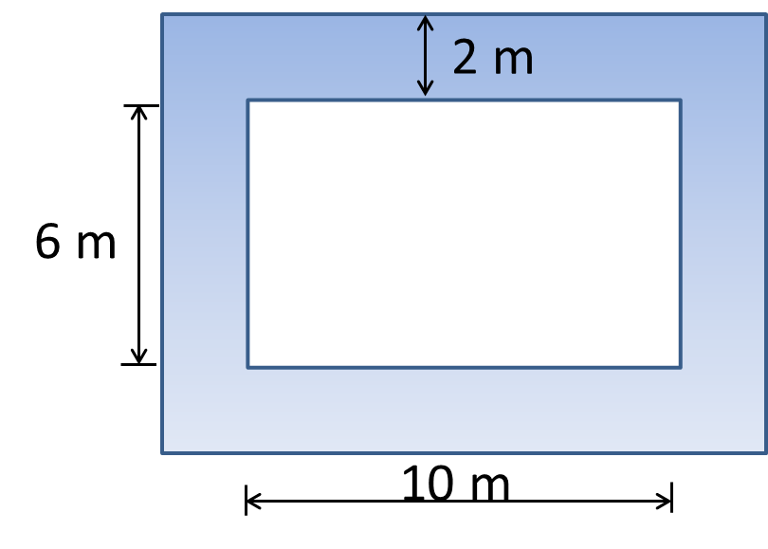

3. Tracy wants to cover the missing portion of his deck with soil in order to grow a garden.
  - Find the missing portion of the deck. Write the expression and evaluate it.

