Name_________________________

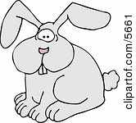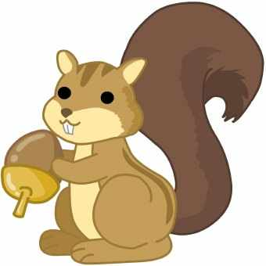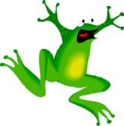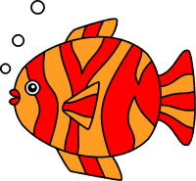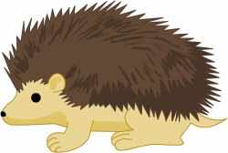

**Why It’s Great Being a**

**____________________**

|  |
| --- |
|  |

**Directions:** Listen carefully as I read the story to you. At each “Stop and Think,” respond to the questions below.

**Stop and Think #1**

1. As a ______________, how do you feel at this point in the story? What questions do you have?

________________________________________________________________________________________________________________________________________________________________________________________________________________________________________________________________________________________________________________________

2. Make a prediction. How do you think the other animals will react to this demand?

________________________________________________________________________________________________________________________________________________________________________________________________________________________________________________________________________________________________________________________

**Stop and Think #2**

3. Make another prediction. What will the others animals do?

________________________________________________________________________________________________________________________________________________________________________________________________________________________________________________________________________________________________________________________

4. Why do you think the other animals will react this way?

________________________________________________________________________________________________________________________________________________________________________________________________________________________________________________________________________________________________________________________

**Stop and Think #3**

5. How do you feel at this point in the story?

________________________________________________________________________________________________________________________________________________________________________________________________________________________________________________________________________________________________________________________

**Stop and Think #4**

6. Make another prediction. What will happen next?

________________________________________________________________________________________________________________________________________________________________________________________________________________________________________________________________________________________________________________________

**Post-Reading Questions**

7. What struck you about this story?

______________________________________________________________________________________________________________________________________________________________________________________________________________________________________________________________________________

8. What is the lesson of the story?

________________________________________________________________________________________________________________________________________________________________________________________________________________________________________________________________________________________________________________________