Class notes for Inequalities in the Real World

Warm-Up: A set has the following values: {2, 4, 6}. Which of the values in this set make the inequality below true?

2x + 6 > 12

Launch:
(ex 1) Mei and Erika are at Six Flags with their families. They see the following sign in front the Dropping Dragon roller coaster. Mei is 56 inches tall and Erika is 49 inches tall.

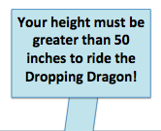
- Who will be able to go on the ride? Why?

- Who will NOT be able to go on the ride? Why not?

- Miguel also wants to go on the Dropping Dragon. What is one height that he could be in order to ride the roller coaster?

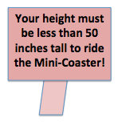
(ex 2) Erika’s little brother, Nick, wants to go on the Mini-Coaster, a roller coaster that is made for little kids only. They see the following sign. Nick is 34 inches tall.

a) Can Nick go on the Mini-Coaster? Why or why not?

b) Can Erika go on the ride with him? Why or why not?

c) Mei’s little brother, Sai, wants to go on the Mini-Coaster. What is one height that he could be to go on this ride?

Turn and Talk: How are these signs similar? How are these signs different?
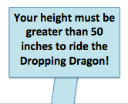

Explore:

Let’s review! What is a variable?

A variable is ___________________________________________________________________.

An example of a variable is ________ or ________.

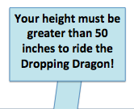
How can we represent this sign using a mathematical statement?

Greater than Less than

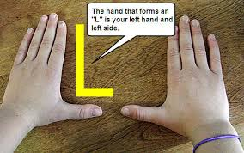
The greater than and less than symbols are called inequalities!
An inequality is a symbol, like > or <, that states that two values are _______ equal.

Let’s try again: How can we represent this sign as a mathematical statement?

Step 1: We find the unknown ________.

Step 2: We pick a _____________.

Step 3: We find the number connected to the _________________.

Step 4: We use an __________________ to connect the variable and the number.

You try: How can we represent this sign as a mathematical statement?

Review Question:
What heights (or values for x) will make that inequality statement above true?

Is there just 1 answer to this problem?

Infinitely many solutions means that we have _______ - _________ answers that will make a math statement true.

Practice:
Write an inequality statement using the variable x to represent each real-world situation below. Then, write 3 possible solutions to each inequality.

(ex 1) Water freezes at any temperature less than 0 degrees Celsius.

(ex 2) Kiera’s weekly allowance is greater than $10.

(ex 3) In his job as a lawyer, Cameron works more than 50 hours per week.

Summary:
A variable is a symbol that Is used to represent an ____________ number. A variable is represented by a letter like _____ or _______.

An inequality is a symbol, like ____ or ____, that states that two values are NOT equal.

infinitely many solutions , means that we have never-ending answers that will make a math statement _____.

Class work for Inequalities in the Real World

For questions #1-5, write an inequality statement using the variable x to represent each real-world situation below. Then, write 3 possible solutions to each inequality.

1) Kelsey needs to make more than 20 cupcakes to have enough for her party.

2) Alexa sleeps less than 9 hours per night.

3) Anyone with a temperature greater than 98.6 degrees Fahrenheit has a fever.

4) An electrician can only use wire that is less than one-eighth of an inch.

5) In order to beat the world record in the Nathan’s Hot Dog eating contest, Joey must eat at least 86 hot dogs in ten
minutes.

For questions #6 and 7, use the information provided to answer each question.
6) In his job as a salesman, Malik must sell more than 5 cars per week.
a) If Malik sells 7 cars, has he sold enough for the week?

b) If Malik sells 5 cars, has he sold enough for the week? Why or why not?

c) If Malik makes $200 per car sold, how many cars will be needed to sell to make $900?

7) Dimitri is saving money for a vacation to New York City with his family. He needs to save more than $150 to have enough spending money.

- Write an inequality to represent how much money Dimitri needs to save for his trip.

- Dimitri works at a pizza place, and makes $10 per hour. How many hours will he need to work to save enough money to have greater than $150?

8) A set has the following values: {1, 3, 5}. Which of the values in this set make the inequality below true?

4x - 1 > 12

