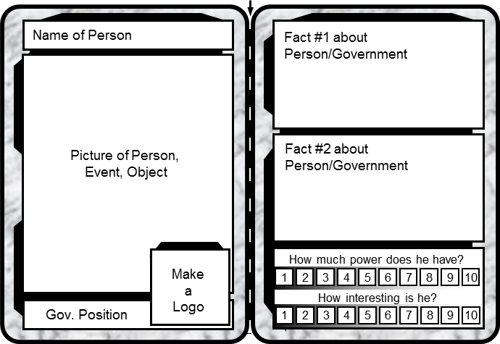
Your Task: Create trading cards for the important leaders of UK,
LEADER TRADING CARDS
Germany, and Russia.
Instructions:
- Fill out each box in the cards below according to the template to the right.
- Be sure to rate how much political power each person has, and how interesting the person is to you.
- Color your pictures and anything else that will make your cards look more realistic.
- Cut out your trading card, fold along the middle, and tape the sides together.

