6NS.6b Name ______________________
Period ____ Date _____________

1. The points (1, 3), (-1, 5), (-3, 3), and (4, -4) have been graphed on the coordinate plane.
Reflect each point across the x-axis. What are the coordinates of the reflected points?

When the star (1, 3) is reflected across the x-axis, the new point is located at _____.

When the triangle (-1, 5) is reflected across the x-axis, the new point is located at
_____.

When the smiley face (-3, 3) is reflected across the x-axis, the new point is located at
_____.

When the lightning bolt (4, -4) is reflected across the x-axis, the new point is located at
_____.

What similarities do you notice between the coordinates of the original point and the
reflected point? ___________________________________________________
________________________________________________________________
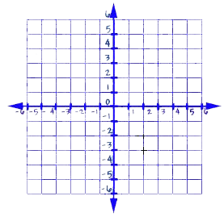

2. The points (1, 3), (-1, 5), (-3, 3), and (4, -4) have been graphed on the coordinate plane.
Reflect each point across the y-axis. What are the coordinates of the reflected points?

When the star (1, 3) is reflected across the y-axis, the new point is located at _____.

When the triangle (-1, 5) is reflected across the y-axis, the new point is located at
_____.

When the smiley face (-3, 3) is reflected across the y-axis, the new point is located at
_____.

When the lightning bolt (4, -4) is reflected across the y-axis, the new point is located at
_____.

What similarities do you notice between the coordinates of the original point and the
reflected point? __________________________________________________

________________________________________________________________

3. The smiley face, located at point (-4, 5), has been reflected across the y-axis.
The new location of the smiley face is (4, 5). Plot it.

What is the distance between (-4, 5) and (4, 5)? ________________________

Write a number sentence using the distance from the y-axis to help justify your answer.
_________________________

4. A point, located at (-3, -4), has been reflected across the x-axis.
The new point has the coordinates (3, -4). Plot it.

What is the distance between (-3, -4) and (3, -4)? _____________________

Write a number sentence using the distance from the x-axis to help justify your answer.

________________________________

