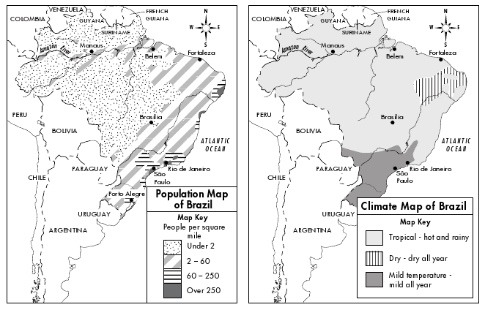

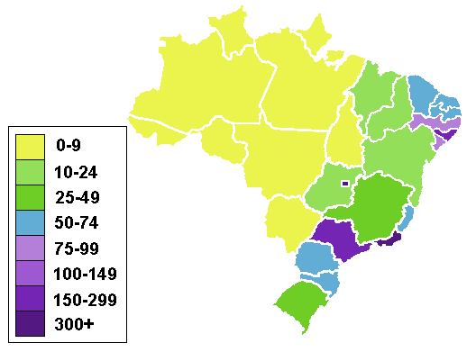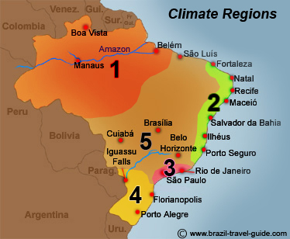 Population Density Map

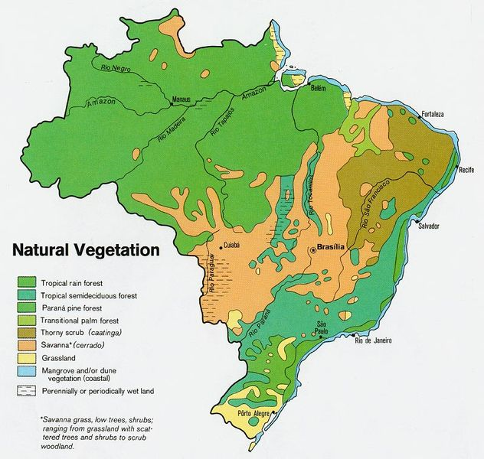

**CLIMATE, TEMPERATURES AND RAIN IN BRAZIL - BRAZILIAN CLIMATE MAP**

**We may consider five big climatic regions in Brazil:**

**The Amazon Basin region (1), with an equatorial climate characterized by agreeable temperatures but plenty of rain and humidity.   
  
The Northeastern Coastlands (2) from Fortaleza to the Bahian south coast, with an all year round travel climate pattern.  
  
The Rio de Janeiro, Vitoria and Sao Paulo coast (3), with a hybrid pattern.  
  
The South States Region (4), with a temperate four season climate pattern; and   
  
The Inland Plateau (5), from the northeast inland to the Pantanal, with a hard dry season and more extreme temperatures.**

**The map above shows the rough configuration of these five climatic regions. Obviously, there are transitional zones and some significant variations within each climate region.**

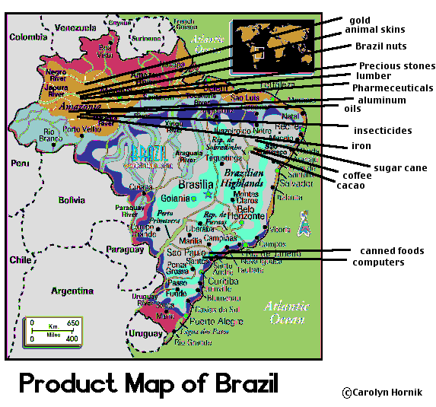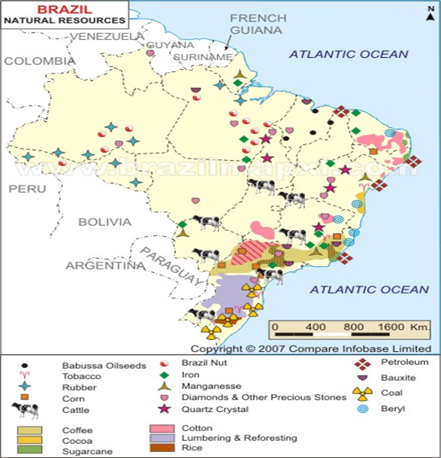

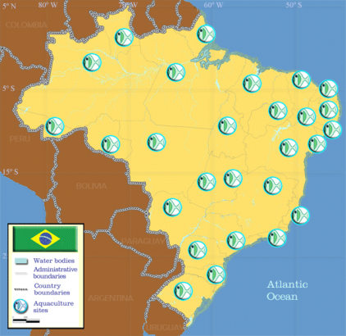

Agricultural Sites

in Brazil

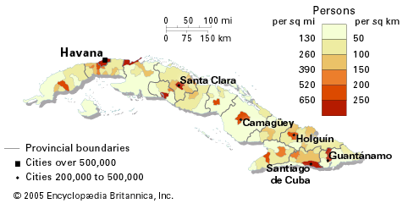**CUBA**

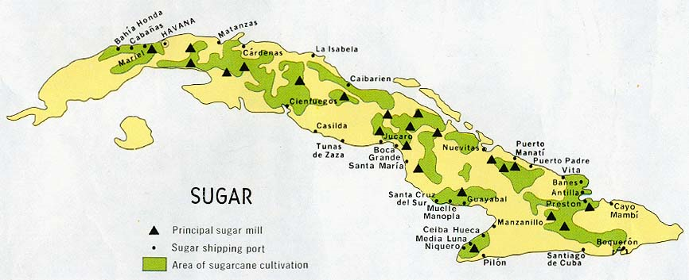

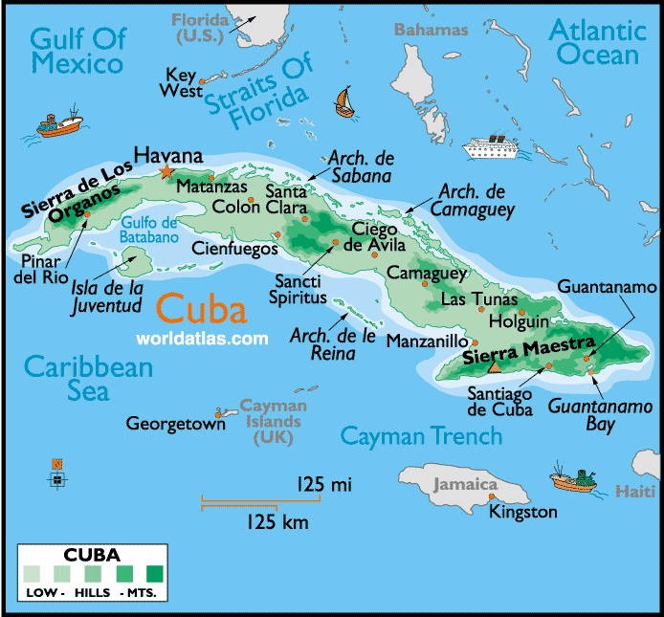

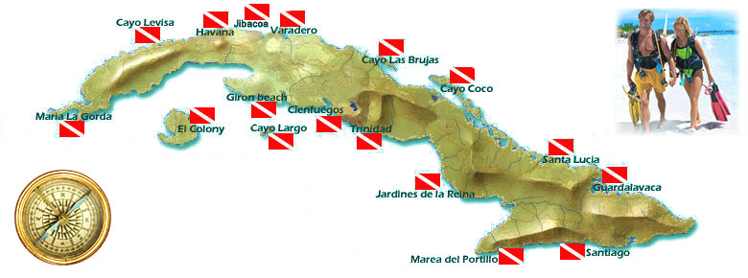

Scuba Sites in Cuba

**Mexico**

Topography Map Population Density Map

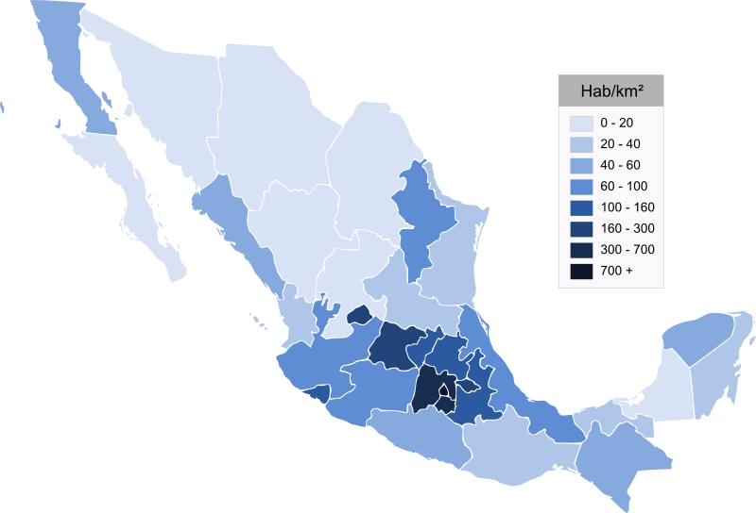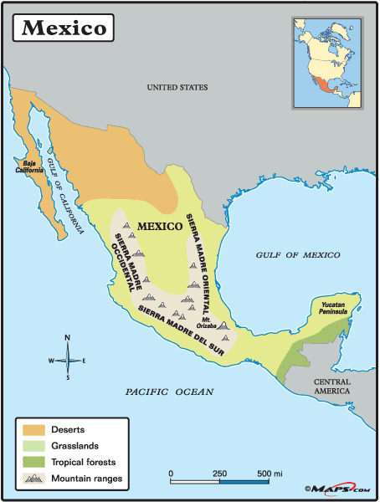

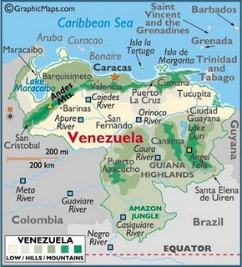**Venezuela**

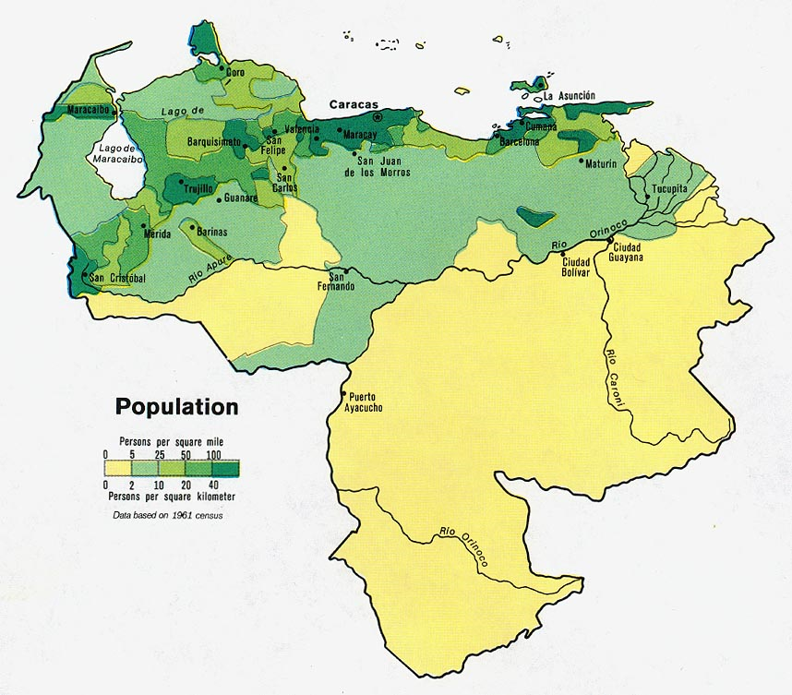 Physical Map Population Density Map