Name ____________________________________
I can compare how the location , climate, and natural resources of Brazil and Cuba affect where people live and how they trade.
I can compare how the location, climate, and natural resources of Mexico and Venezuela affect where people live and how they trade.
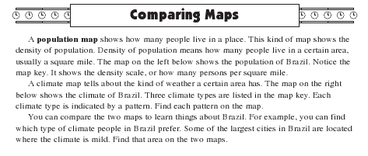

- About how many people per sq. mile live in Belem? _______________
- What kind of climate is found around Belem? _______________
- About how many people per sq. mile live in Rio de Janeiro? _______________
- What kind of climate is found around Rio? _______________
- What kind of climate does the Amazon River pass through? ______________
- Much of Brazil is covered by rain forest. What kind of climate would probably be found
in the rain forest? _______________
- Do more people live near the coast or in the middle of Brazil? ______________
- Why do you think many people in Brazil choose to live near the coast?
________________________________________________________________
________________________________________________________________
________________________________________________________________

Look at the population density map, the vegetation map, and the climate map for Brazil.

9. What relationship do you see between population density, vegetation, and climate
regions?
________________________________________________________________
________________________________________________________________
________________________________________________________________

10. How might the location of natural resources and the location of farms threaten the
Rainforests?
________________________________________________________________
________________________________________________________________
________________________________________________________________

Cuba - Look at these maps.
11. With your partner, come up with a hypothesis to explain why some areas of Cuba might
be more densely populated than others.
________________________________________________________________
________________________________________________________________
________________________________________________________________

12. Look at these great scuba diving spots. Why do you find very few US citizens diving
here? In what way does that affect Cuba’s economy?
________________________________________________________________
________________________________________________________________
________________________________________________________________

Mexico – Look at these maps.

13. Study the topography of Mexico, then look at the population density map. What
conclusions can you draw looking at the two maps?
________________________________________________________________
________________________________________________________________
________________________________________________________________

Venezuela – Look at these maps.

14. Notice that most people live along the coast or in the highlands. Look at the yellow
part of the population map. Why do you suppose so few people live in the large area
that is covered in yellow?
________________________________________________________________
________________________________________________________________
________________________________________________________________

